**3.2 Circuit Diagram:**

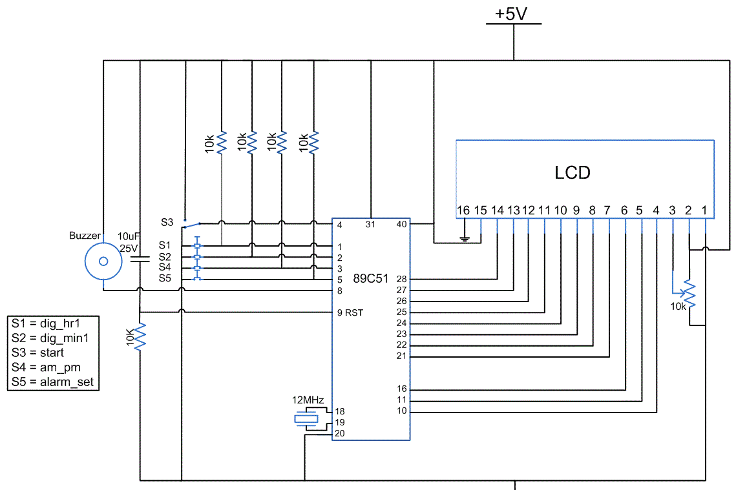

Figure 3.2: Circuit Diagram of LCD and buzzer interfacing with Microcontroller

As seen from the figure 3.2, different components are interfaced to the microcontroller, some are directly connected, some are interfaced through serial communication. Power supply is connected to the VCC and GND. MAX232 IC is connected to the RXD and TXD pins of port C i.e. 26 and 25. it is used for serial communication. Crystal is given to CLKIN and CLKOUT pins of 18 and 19. Reset is at pin number 9.

**3.3 Hardware Description:**

**3.3.1. Microcontroller:**



Figure 3.3: AT89S52

**3.3.1.1. Analog features:**

* Compatible with MCS®-51 Products

• 8K Bytes of In-System Programmable (ISP) Flash Memory

• 4.0V to 5.5V Operating Range

• Fully Static Operation: 0 Hz to 33 MHz

• Three-level Program Memory Lock Programmable input multiplexing from device

* inputs and internal voltage reference
* Comparator outputs are externally accessible

**3.3.1.2 Peripheral Features:**

• 256 x 8-bit Internal RAM

• 32 Programmable I/O Lines

• Three 16-bit Timer/Counters

• Eight Interrupt Sources

• Full Duplex UART Serial Channel

• Low-power Idle and Power-down Modes

• Interrupt Recovery from Power-down Mode

**3.3.1.3. Special Microcontroller Features:**

• Watchdog Timer

• Dual Data Pointer

• Power-off Flag

• Fast Programming Time

• Flexible ISP Programming (Byte and Page Mode)

• Green (Pb/Halide-free) Packaging Option

**3.3.1.4. Pin Diagram:**

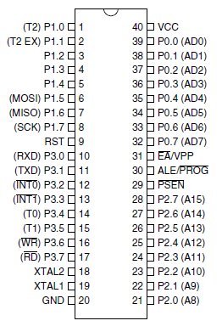

Figure.3.4: Pin diagram

### 3.3.1.6. Input/output ports

The AT89S52 is a low-power, high-performance CMOS 8-bit microcontroller with 8K bytes of in-system programmable Flash memory. The device is manufactured using Atmel’s high-density nonvolatile memory technology and is compatible with the industry standard 80C51 instruction set and pin out. The on-chip Flash allows the program memory to be reprogrammed in-system or by a conventional non volatile memory programmer. By combining a versatile 8-bit CPU with in-system programmable Flash on a monolithic chip, the Atmel AT89S52 is a powerful microcontroller which provides a highly-flexible and cost-effective solution to many embedded control applications. The AT89S52 provides the following standard features: 8K bytes of Flash, 256 bytes of RAM, 32 I/O lines, Watchdog timer, two data pointers, three 16-bit timer/counters, a six-vector two-level interrupt architecture, a full duplex serial port, on-chip oscillator, and clock circuitry. In addition, the AT89S52 is designed with static logic for operation down to zero frequency and supports two software selectable power saving modes. The Idle Mode stops the CPU while allowing the RAM, timer/counters, serial port, and interrupt system to continue functioning. The Power-down mode saves the RAM con-tents but freezes the oscillator, disabling all other chip functions until the next interrupt or hardware reset.

**3.3.3. MAX232:**

The MAX232 is an IC, first created in 1987 by [Maxim Integrated Products](http://en.wikipedia.org/wiki/Maxim_Integrated_Products), that converts signals from an [RS-232](http://en.wikipedia.org/wiki/RS-232) serial port to signals suitable for use in [TTL](http://en.wikipedia.org/wiki/Transistor-transistor_logic) compatible digital logic circuits. The MAX232 is a dual driver/receiver and typically converts the RX, TX, CTS and RTS signals.

The drivers provide RS-232 voltage level outputs (approx. ± 7.5 [V](http://en.wikipedia.org/wiki/Volt)) from a single + 5 V supply via on-chip [charge pumps](http://en.wikipedia.org/wiki/Charge_pump) and external capacitors. This makes it useful for implementing RS-232 in devices that otherwise do not need any voltages outside the 0 V to + 5 V range, as [power supply](http://en.wikipedia.org/wiki/Power_supply) design does not need to be made more complicated just for driving the RS-232 in this case.

The receivers reduce RS-232 inputs (which may be as high as ± 25 V), to standard 5 V [TTL](http://en.wikipedia.org/wiki/Transistor-transistor_logic) levels. These receivers have a typical threshold of 1.3 V, and a typical [hysteresis](http://en.wikipedia.org/wiki/Hysteresis) of 0.5 V.

**3.3.3.1. Voltage Levels:**

Table 3.1: RS 232 Voltage Levels

|  |  |  |
| --- | --- | --- |
| **RS232 line type and logic level** | **RS232 voltage** | **TTL voltage to/from MAX232** |
| Data transmission (Rx/Tx) logic 0 | +3 V to +15 V | 0 V |
| Data transmission (Rx/Tx) logic 1 | -3 V to -15 V | 5 V |
| Control signals (RTS/CTS/DTR/DSR) logic 0 | -3 V to -15 V | 5 V |
| Control signals (RTS/CTS/DTR/DSR) logic 1 | +3 V to +15 V | 0 V |

It is helpful to understand what occurs to the voltage levels. When a MAX232 IC receives a TTL level to convert, it changes TTL logic 0 to between +3 and +15 V, and changes TTL logic 1 to between -3 to -15 V, and vice versa for converting from RS232 to TTL. This can be confusing when you realize that the RS232 data transmission voltages at a certain logic state are opposite from the RS232 control line voltages at the same logic state. To clarify the matter, see the table above.

In [telecommunication](http://en.wikipedia.org/wiki/Telecommunication) and computer science, serial communication is the process of sending [data](http://en.wikipedia.org/wiki/Data) one [bit](http://en.wikipedia.org/wiki/Bit) at a time, sequentially, over a [communication channel](http://en.wikipedia.org/wiki/Communication_channel) or [computer bus](http://en.wikipedia.org/wiki/Computer_bus). This is in contrast to [parallel communication](http://en.wikipedia.org/wiki/Parallel_communication), where several bits are sent as a whole, on a link with several parallel channels.

Serial communication is used for all long-haul communication and most [computer networks](http://en.wikipedia.org/wiki/Computer_network), where the cost of cable and [synchronization](http://en.wikipedia.org/wiki/Synchronization) difficulties make parallel communication impractical. Serial computer buses are becoming more common even at shorter distances, as improved [signal integrity](http://en.wikipedia.org/wiki/Signal_integrity) and transmission speeds in newer serial technologies have begun to outweigh the parallel bus's advantage of simplicity (no need for serializer and deserializer, or [SerDes](http://en.wikipedia.org/wiki/SerDes)) and to outstrip its disadvantages ([clock skew](http://en.wikipedia.org/wiki/Clock_skew), interconnect density). The migration from [PCI](http://en.wikipedia.org/wiki/Peripheral_Component_Interconnect) to [PCI Express](http://en.wikipedia.org/wiki/PCI_Express) is an example.

In [telecommunications](http://en.wikipedia.org/wiki/Telecommunications), RS-232 is a [standard](http://en.wikipedia.org/wiki/Technical_standard) for [serial communication](http://en.wikipedia.org/wiki/Serial_communication) transmission of data. It formally defines the signals connecting between a DTE ([data terminal equipment](http://en.wikipedia.org/wiki/Data_terminal_equipment)) such as a [computer terminal](http://en.wikipedia.org/wiki/Computer_terminal), and a DCE ([data circuit-terminating equipment](http://en.wikipedia.org/wiki/Data_circuit-terminating_equipment), originally defined as data communication equipment), such as a [modem](http://en.wikipedia.org/wiki/Modem). The RS-232 standard is commonly used in [computer](http://en.wikipedia.org/wiki/Computer) [serial ports](http://en.wikipedia.org/wiki/Serial_port). The standard defines the electrical characteristics and timing of signals, the meaning of signals, and the physical size and [pin out](http://en.wikipedia.org/wiki/Pinout) of connectors. The current version of the standard is TIA-232-F Interface between Data Terminal Equipment and Data Circuit-Terminating Equipment Employing Serial Binary Data Interchange, issued in 1997.

An RS-232 [serial port](http://en.wikipedia.org/wiki/Serial_port) was once a standard feature of a [personal computer](http://en.wikipedia.org/wiki/Personal_computer), used for connections to [modems](http://en.wikipedia.org/wiki/Modem), printers, mice, data storage, [uninterruptible power supplies](http://en.wikipedia.org/wiki/Uninterruptible_power_supplies), and other peripheral devices. However, RS-232 is hampered by low transmission speed, large voltage swing, and large standard connectors. In modern personal computers, [USB](http://en.wikipedia.org/wiki/Universal_Serial_Bus) has displaced RS-232 from most of its peripheral interface roles. Many computers do not come equipped with RS-232 ports and must use either an external USB-to-RS-232 converter or an internal expansion card with one or more serial ports to connect to RS-232 peripherals. RS-232 devices are widely used, especially in industrial machines, networking equipment and scientific instruments.

In RS-232, user data is sent as a [time-series](http://en.wikipedia.org/wiki/Time-series) of [bits](http://en.wikipedia.org/wiki/Bit). Both synchronous and asynchronous transmissions are supported by the standard. In addition to the data circuits, the standard defines a number of control circuits used to manage the connection between the DTE and DCE. Each data or control circuit only operates in one direction that is, signaling from a DTE to the attached DCE or the reverse. Since transmit data and receive data are separate circuits, the interface can operate in a [full duplex](http://en.wikipedia.org/wiki/Full_duplex) manner, supporting concurrent data flow in both directions. The standard does not define character framing within the data stream, or character encoding.

The RS-232 standard defines the voltage levels that correspond to logical one and logical zero levels for the data transmission and the control signal lines. Valid signals are either in the range of +3 to +15 volts or the range −3 to −15 volts with respect to the ground/common pin; consequently, the range between −3 to +3 volts is not a valid RS-232 level. For data transmission lines (TxD, RxD and their secondary channel equivalents) logic one is defined as a negative voltage, the signal condition is called "mark". Logic zero is positive and the signal condition is termed "space". Control signals have the opposite polarity: the asserted or active state is positive voltage and the deasserted or inactive state is negative voltage. Examples of control lines include request to send (RTS), clear to send (CTS), [data terminal ready](http://en.wikipedia.org/wiki/Data_terminal_ready) (DTR), and data set ready (DSR).

The standard specifies a maximum open-circuit voltage of 25 volts: signal levels of ±5 V, ±10 V, ±12 V, and ±15 V are all commonly seen depending on the voltages available to the line driver circuit. Some RS-232 driver chips have inbuilt circuitry to produce the required voltages from a 3 or 5 volt supply. RS-232 drivers and receivers must be able to withstand indefinite short circuit to ground or to any voltage level up to ±25 volts. The [slew rate](http://en.wikipedia.org/wiki/Slew_rate), or how fast the signal changes between levels, is also controlled.

Because the voltage levels are higher than logic levels typically used by integrated circuits, special intervening driver circuits are required to translate logic levels. These also protect the device's internal circuitry from short circuits or transients that may appear on the RS-232 interface, and provide sufficient current to comply with the slew rate requirements for data transmission.

Because both ends of the RS-232 circuit depend on the ground pin being zero volts, problems will occur when connecting machinery and computers where the voltage between the ground pin on one end and the ground pin on the other is not zero. This may also cause a hazardous [ground loop](http://en.wikipedia.org/wiki/Ground_loop_(electricity)). Use of a common ground limits RS-232 to applications with relatively short cables. If the two devices are far enough apart or on separate power systems, the local ground connections at either end of the cable will have differing voltages; this difference will reduce the noise margin of the signals. Balanced, differential, serial connections such as USB, [RS-422](http://en.wikipedia.org/wiki/RS-422) and[RS-485](http://en.wikipedia.org/wiki/RS-485) can tolerate larger ground voltage differences because of the differential signaling.

Unused interface signals terminated to ground will have an undefined logic state. Where it is necessary to permanently set a control signal to a defined state, it must be connected to a voltage source that asserts the logic 1 or logic 0 level, for example with a pull up resistor. Some devices provide test voltages on their interface connectors for this purpose.

**3.3.3.2. Applications:**

The MAX232 (A) has two receivers (converts from RS-232 to TTL voltage levels), and two drivers (converts from TTL logic to RS-232 voltage levels). This means only two of the RS-232 signals can be converted in each direction. Typically, a pair of a driver/receiver of the MAX232 is used for TX and RX signals, and the second one for CTS and RTS signals.

There are not enough drivers/receivers in the MAX232 to also connect the DTR, DSR, and DCD signals. Usually these signals can be omitted when e.g. communicating with a PC's serial interface. If the DTE really requires these signals, either a second MAX232 is needed, or some other IC from the MAX232 family can be used. Also, it is possible to directly wire DTR (DB9 pin #4) to DSR (DB9 pin #6) without going through any circuitry. This gives automatic (brain dead) DSR acknowledgment of an incoming DTR signals.

### 3.3.4 LCD DISPLAY

Liquid crystal displays (LCDs) have materials which combine the properties of both liquids and crystals. Rather than having a melting point, they have a temperature range within which the molecules are almost as mobile as they would be in a liquid, but are grouped together in an ordered form similar to a crystal.

An LCD consists of two glass panels, with the liquid crystal material sand witched in between them. The inner surface of the glass plates are coated with transparent electrodes which define the character, symbols or patterns to be displayed polymeric layers are present in between the electrodes and the liquid crystal, which makes the liquid crystal molecules to maintain a defined orientation angle. One each polarizer are pasted outside the two glass panels. This polarizer would rotate the light rays passing through them to a definite angle, in a particular direction

When the LCD is in the off state, light rays are rotated by the two polarisers and the liquid crystal, such that the light rays come out of the LCD without any orientation, and hence the LCD appears transparent.

When sufficient voltage is applied to the electrodes, the liquid crystal molecules would be aligned in a specific direction. The light rays passing through the LCD would be rotated by the polarizer, which would result in activating / highlighting the desired characters. The LCD’s are lightweight with only a few millimeters thickness. Since the LCD’s consume less power, they are compatible with low power electronic circuits, and can be powered for long durations. The LCD doesn’t generate light and so light is needed to read the display. By using backlighting, reading is possible in the dark. The LCD’s have long life and a wide operating temperature range.

Changing the display size or the layout size is relatively simple which makes the LCD’s more customer friendly. The LCDs used exclusively in watches, calculators and measuring instruments are the simple seven-segment displays, having a limited amount of numeric data. The recent advances in technology have resulted in better legibility, more information displaying capability and a wider temperature range. These have resulted in the LCDs being extensively used in telecommunications and entertainment electronics. The LCDs have even started replacing the cathode ray tubes (CRTs) used for the display of text and graphics, and also in small TV applications. This section describes the operation modes of LCD’s then describe how to program and interface an LCD to 8051 using Assembly and C.

**3.3.4.1 Principle of operation:**

In recent years the LCD is finding widespread use replacing LED s (seven-segment LED s or other multi-segment LED s).This is due to the following reasons:

* The declining prices of LCDs.
* The ability to display numbers, characters and graphics. This is in contrast to LED which is limited to numbers and a few characters.
* Incorporation of a refreshing controller into the LCD, there by relieving the CPU of the task of refreshing the LCD. In the case of LED s, they must be refreshed by the CPU to keep on displaying the data.
* Ease of programming for characters and graphics.

The LCD discussed in this section has 14 pins. The function of each pin is given in table.

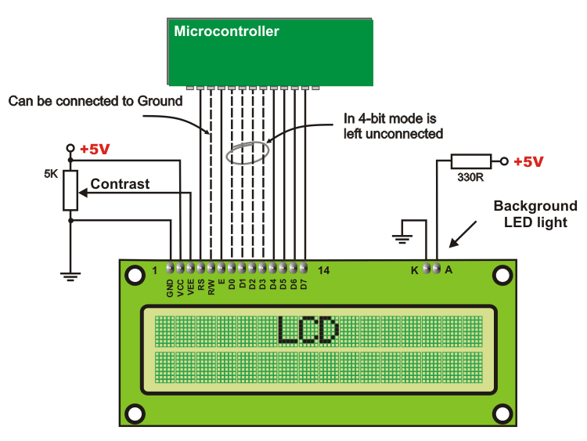

Figure 3.5: Connection of LCD with Microcontroller

Data corresponds to the ASCII value of the character to be printed. This can be done by placing the ASCII value on the LCD Data lines and selecting the Data Register of the LCD by selecting the RS (Register Select) pin. Each and every display location is accessed and controlled by placing respective command on the data lines and selecting the Command Register of LCD by selecting the (Register Select) RS pin.

This component is specifically manufactured to be used with microcontrollers, which means that it cannot be activated by standard IC circuits. It is used for displaying different messages on a miniature liquid crystal display. The model described here is for its low price and great capabilities most frequently used in practice. It is based on the HD44780 microcontroller (*Hitachi*) and can display messages in two lines with 16 characters each. It can display all the letters of alphabet, Greek letters, punctuation marks, mathematical symbols etc. It is also possible to display symbols made up by the user. Other useful features include automatic message shift (left and right), cursor appearance, LED backlight etc.

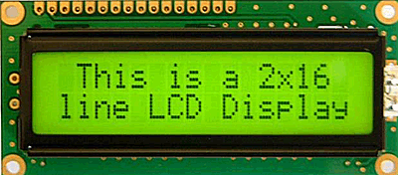

#### Figure.3.6: LCD display

#### 3.3.4. 2. LCD Screen

An LCD screen can display two lines with 16 characters each. Every character consists of 5x8 or 5x11 dot matrix. This book covers a 5x8 character display which is most commonly used.

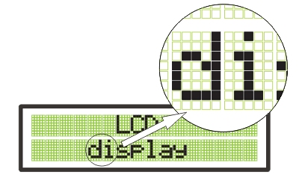

Figure.3.7. LCD character display

Display contrast depends on the power supply voltage and whether messages are displayed in one or two lines. For this reason, varying voltage 0-Vdd is applied to the pin marked as Vee. A trimmer potentiometer is usually used for this purpose. Some of the LCD displays have built-in backlight (blue or green LEDs). When used during operation, a current limiting resistor should be serially connected to one of the pins for backlight power supply (similar to LED diodes).

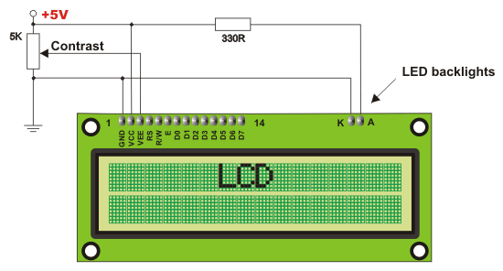

Figure.3.8: LCD connection diagram

If there are no characters displayed or if all of them are dimmed when the display is switched on, the first thing that should be done is to check the potentiometer for contrast adjustment. Is it properly adjusted. The same applies if the mode of operation has been changed (writing in one or two lines).

Table 3.2: Pin Description of LCD

|  |  |  |  |
| --- | --- | --- | --- |
| **Pin** | **Symbol** | **I/O** | **Description** |
| 1 | Vss | -- | Ground |
| 2 | Vcc | -- | +5V power supply |
| 3 | VEE | -- | Power supply to control contrast |
| 4 | RS | I | RS=0 to select command register  RS=1 to select data register |
| 5 | R/W | I | R/W=0 for write  R/W=1 for read |
| 6 | E | I/O | Enable |
| 7 | DB0 | I/O | The 8-bit data bus |
| 8 | DB1 | I/O | The 8-bit data bus |
| 9 | DB2 | I/O | The 8-bit data bus |
| 10 | DB3 | I/O | The 8-bit data bus |
| 11 | DB4 | I/O | The 8-bit data bus |
| 12 | DB5 | I/O | The 8-bit data bus |
| 13 | DB6 | I/O | The 8-bit data bus |
| 14 | DB7 | I/O | The 8-bit data bus |

Table 3.3. LCD Command Code

|  |  |
| --- | --- |
| **Code (hex)** | **Command to LCD Instruction Register** |
| 1 | Clear display screen |
| 2 | Return home |
| 4 | Decrement cursor |
| 6 | Increment cursor |
| 5 | Shift display right |
| 7 | Shift display left |
| 8 | Display off, cursor off |
| A | Display off, cursor on |
| C | Display on, cursor off |
| E | Display on, cursor on |
| F | Display on, cursor blinking |
| 10 | Shift cursor position to left |
| 14 | Shift cursor position to right |
| 18 | Shift the entire display to the left |
| 1C | Shift the entire display to the right |
| 80 | Force cursor to beginning of 1st line |
| C0 | Force cursor to beginning of 2nd line |

**3.3.4.3. Uses:**

The LCDs used exclusively in watches, calculators and measuring instruments are the simple seven-segment displays, having a limited amount of numeric data. The recent advances in technology have resulted in better legibility, more information displaying capability and a wider temperature range. These have resulted in the LCDs being extensively used in telecommunications and entertainment electronics.

So in this project, the LCD is used to display the instantaneous information. The information may be prompting or alerting or instructing the user. Name of zone and zone Speed limit are displayed on the LCD.

**3.4 SOFTWARE DESCRIPTION**:

**3.4.1. Design Issues**

The most important aspect of implementing a machine vision system is the image acquisition. Any deficiencies in the acquired images can cause problems with image analysis and interpretation. Examples of such problems are a lack of detail due to insufficient contrast or poor positioning of the camera: this can cause the objects to be unrecognizable, so the purpose of vision cannot be fulfilled.

**3.4.2. Illumination**

A correct illumination scheme is a crucial part of insuring that the image has the correct amount of contrast to allow to correctly process the image. In case of the drowsy driver detection system, the light source is placed in such a way that the maximum light being reflected back is from the face. The driver’s face will be illuminated using a 60W light source. To prevent the light source from distracting the driver, an 850nm filter is placed over the source. Since 850nm falls in the infrared region, the illumination cannot be detected by the human eye, and hence does not agitate the driver. Since the algorithm behind the eye monitoring system is highly dependant on light, the following important illumination factors to consider are:

1. Different parts of objects are lit differently, because of variations in the angle of incidence, and hence have different brightness as seen by the camera.

2. Brightness values vary due to the degree of reflectivness of the object.

3. Parts of the background and surrounding objects are in shadow, and can also affect the brightness values in different regions of the object.

4. Surrounding light sources (such as daylight) can diminish the effect of the light source on the object.

**3.4.3. Camera Hardware**

The next item to be considered in image acquisition is the video camera. Review of several journal articles reveals that face monitoring systems use an infrared-sensitive camera to generate the eye images [3],[5],[6],[7]. This is due to the infrared light source used to illuminate the driver’s face. CCD cameras have a spectral range of 400-1000nm, and peak at approximately 800nm. The camera used in this system is a Sony CCD black and white camera. CCD camera digitize the image from the outset, although in one respect – that signal amplitude represents light intensity – the image is still analog.

**3.4.4. Frame grabbers and captured hardware**

The next stage of any image acquisition system must convert the video signal into a format, which can be processed by a computer. The common solution is a frame grabber board that attaches to a computer and provides the complete video signal to the computer. The resulting data is an array of greyscale values, and may then be analysed by a processor to extract the required features. Two options were investigated when choosing the system’s capture hardware. The first option is designing a homemade frame grabber, and the second option is purchasing a commercial frame grabber. The two options are discussed below.

**3.4.5. Homemade Frame grabbers**

Initially, a homemade frame grabber was going to be used. The design used was based on the ‘Dirt Cheap Frame Grabber (DCFG)’, developed by Michael Day [2]. A detailed circuit description of the DCFG is beyond the scope of this report, but important observations of this design were made. The DCFG assumes that the video signal will be NTSC type compiling to the RS170 video standard. Although the DCFG successfully grabs the video signal and digitizes it, the limitation to this design was that the parallel port could not transfer the signal fast enough for real-time purposes. The DCFG was tested on two different computers, a PC (Pentium I – 233MHz) and a laptop (Pentium III – 700MHz). The laptop parallel port was much slower than the PC’s. Using the PC, which has a parallel port of 4MHz, it was calculated that it would take approximately a minute to transfer a 480 x 640 pixel image. Because of the slow transfer rate of the parallel port it was concluded that this type of frame grabber could not be used. Another option was to build a frame grabber similar to the commercial versions. This option was not pursued, since the main objective of the project is not to build a frame grabber. Building a complete frame grabber is a thesis project in itself, and since the parallel port design could not be used for real-time applications, the final option was purchasing a commercial frame grabber.

**3.4.6. Commercial Frame grabbers**

The commercial frame grabber chosen for this system is the Euresys Picolo I. The Picolo frame grabber acquired both colour and monochrome image formats. The Picolo supports the acquisition and the real-time transfer of full resolution colour images (up to 768 x 576 pixels) and sequences of images to the PC memory (video capture). The board supports PCI bus mastering; images are transferred to the PC memory using DMA in parallel with the acquisition and processing. With the commercial board, it is also easier to write software to process the images for each systems own application. The board comes with various drivers and libraries for different software (i.e.; Borland C, Java, etc). The drivers allow the controlling of capturing and processing of images via custom code.

**3.5 DESIGN**

This chapter aims to present my design of the Drowsy Driver Detection System. Each design decision will be presented and rationalized, and sufficient detail will be given to allow the reader to examine each element in its entirety.

**3.5.1. Design Concept**

As seen in the various references [3],[5],[6],[7],[8],[9], there are several different algorithms and methods for eye tracking, and monitoring. Most of them in some way relate to features of the eye (typically reflections from the eye) within a video image of the driver. The original aim of this project was to use the retinal reflection (only) as a means to finding the eyes on the face, and then using the absence of this reflection as a way of detecting when the eyes are closed. It was then found that this method might not be the best method of monitoring the eyes fort two reasons. First, in lower lighting conditions, the amount of retinal reflection decreases; and second, if the person has small eyes the reflection may not show, as seen below in Figure 3.9.



**Figure 3.9: Case where no retinal reflection present.**

As the project progressed, the basis of the horizontal intensity changes idea from paper [7] was used. One similarity among all faces is that eyebrows are significantly different from the skin in intensity, and that the next significant change in intensity, in the y-direction, is the eyes. This facial characteristic is the centre of finding the eyes on the face, which will allow the system to monitor the eyes and detect long periods of eye closure. Each of the following sections describes the design of the drowsy driver detection system.

**3.5.2. System Configuration**

Because the eye tracking system is based on intensity changes on the face, it is crucial that the background does not contain any object with strong intensity changes. Highly reflective object behind the driver, can be picked up by the camera, and be consequently mistaken as the eyes. Since this design is a prototype, a controlled lighting area was set up for testing. Low surrounding light (ambient light) is also important, since the only significant light illuminating the face should come from the drowsy driver system. If there is a lot of ambient light, the effect of the light source diminishes. The testing area included a black background, and low ambient light (in this case, the ceiling light was physically high, and hence had low illumination). This setup is somewhat realistic since inside a vehicle, there is no direct light, and the background is fairly uniform.

**3.5.3. Camera**

The drowsy driver detection system consists of a CCD camera that takes images of the driver’s face. This type of drowsiness detection system is based on the use of image processing technology that will be able to accommodate individual driver differences. The camera is placed in front of the driver, approximately 30 cm away from the face. The camera must be positioned such that the following criteria are met:

1. The driver’s face takes up the majority of the image.

2. The driver’s face is approximately in the centre of the image.

The facial image data is in 480x640 pixel format and is stored as an array through the predefined Picolo driver functions (as described in a later section).

**3.5.4. Light Source**

For conditions when ambient light is poor (night time), a light source must be present to compensate. Initially, the construction of an infrared light source using infrared LED was going to be implemented. It was later found that at least 50 LEDs would be needed so create a source that would be able to illuminate the entire face. To cut down cost, a simple desk light was used. Using the desk light alone could not work, since the bright light is blinding if looked at directly, and could not be used to illuminate the face. However, light from light bulbs and even daylight all contain infrared light; using this fact, it was decided that if an infrared filter was placed over the desk lamp, this would protect the eyes from a strong and distracting light and provide strong enough light to illuminate the face. A wideband infrared filter was placed over the desk lamp, and provides an excellent method of illuminating the face. The spectral plot of the filter is shown in Appendix A. The prototype of the Drowsy Driver Detection System is shown in Photo 3.1.



**Photo 3.1: Photograph of Drowsy Driver Detection System prototype**